**NATURAL DISASTER INTENSITY ANALYSIS AND CLASSIFICATION USING ARTIFICIAL INTELLIGENCE**

**TEAM ID**: LTVIP2023TMID08367

**TEAM LEADER**: AIESHA MUSKAN

**TEAM MEMBER**: SHAIK MAHAMMAD KAIF

**TEAM MEMBER**: SUBHANS SINGH

**TEAM MEMBER**: S.AFREEN

**TEAM MEMBER**: G.LAVANYA

**TEAM MEMBER**: KUTAGULA ASIFMOHAMMAD

## TABLE OF CONTENTS

1. **INTRODUCTION** 
   1. Project Overview
   2. Purpose
2. **REQUIREMENT ANALYSIS** 
   1. Functional requirement
   2. Non-Functional requirements
3. **PROJECT DESIGN** 
   1. Data Flow Diagrams
   2. Solution & Technical Architecture
   3. User Stories
4. **PROJECT PLANNING & SCHEDULING** 
   1. Sprint Planning & Estimation
   2. Sprint Delivery Schedule 6.3 Reports from JIRA

1. **CODING & SOLUTIONING**
   1. Feature 1
   2. Feature 2
   3. Database Schema
2. **TESTING** 
   1. Test Cases
   2. User Acceptance Testing
3. **RESULTS** 
   1. Performance Metrics
4. **CONCLUSION**
5. **FUTURE SCOPE**

## 1.INTRODUCTION

### 1.1 PROJECT OVERVIEW

Natural disasters are large-scale geological or meteorological events that have the potential to cause loss of life or property. A disaster is a result of a natural or man-made hazard impacting a vulnerable community. It is the combination of the hazard along with exposure of a vulnerable society that results in a disaster. The project aims at building a deep learning model that can classify and tell the intensity of a natural disaster based on images. The project uses a multilayered deep convolutional neural network as the main model architecture and also it uses various techniques to enhance the model performance and robustness such as data augmentation, transfer learning, and ensemble methods. The project can have various applications and use cases for disaster management and response such as providing timely and accurate information, assessing the damage and impact, and facilitating the recovery and reconstruction.

### 1.2 PURPOSE

The purpose of natural disaster intensity analysis and classification using AI is to build a deep learning model that can classify and tell the intensity of a natural disaster based on images. This can help to overcome losses in ecosystems, human lives, and properties by providing timely and accurate information for disaster management and response. It can also be integrated with other technologies such as geographic information systems, remote sensing, and social media to provide a comprehensive and multidimensional view of the disaster situation and impact.

## 2. REQUIREMENT ANALYSIS

### 2.1 FUNCTIONAL REQUIREMENTS

The following are the functional requirements of the proposed solution.

|  |  |  |
| --- | --- | --- |
| **FR**  **No.** | **Functional Requirement**  **(Epic)** | **Sub Requirement (Story / Sub-Task)** |
| FR-1 | **LOGIN** | Login by giving a mobile number, gmail or google account and their loca on. |
| FR-2 | **ALERT** | The alert message is given to all the users when the cyclone hits. |
| FR-3 | **MONITORING** | Continuous monitoring of cyclones and climate changes. |
| FR-4 | **REPORTS** | Keeping the records of the previous cyclone and refer news from meteorologist for live updates. |
| FR-5 | **END USERS** | The information is sent to the farmers using the database. |
| FR-6 | **END GOAL** | Inform farmers about the cyclone and its intensity. |

## 2 .2 NON-FUNCTIONAL REQUIREMENTS

The following are the non-functional requirements of the proposed solution :

|  |  |  |
| --- | --- | --- |
| **FR**  **No.** | **Non-Functional Requirement** | **Description** |
| NFR-  1 | **USABILITY** | While using this system, people turn on their current loca on. They receive alert messages as no fica on. The local officials can also inform and guide their nearby people and farmers by an alert message. |
| NFR-  2 | **SECURITY** | It does not share any personal informa on to strangers. Their informa on is to be encrypted and |
| NFR-  3 | **RELIABILITY** | As the details collected from satellite image and meteorologist and updated details in this system, so it is trustworthy. |
| NFR-  4 | **PERFORMANCE** | It runs in minimum storage space.  It will run efficiently when 1000 users login the same time. |

|  |  |  |
| --- | --- | --- |
| NFR-  5 | **AVAILABILITY** | It should be available in all Android phones and laptops. |
| NFR-  6 | **SCALABILITY** | As the product we created is user friendly and it will be very useful for farmers and agriculture. |

**3**. **PROJECT DESIGN**

### 3.1 DATA FLOW DIAGRAM

A data-flow diagram is a way of representing a flow of data through a process or a system. The DFD also provides information about the outputs and inputs of each entity and the process itself.

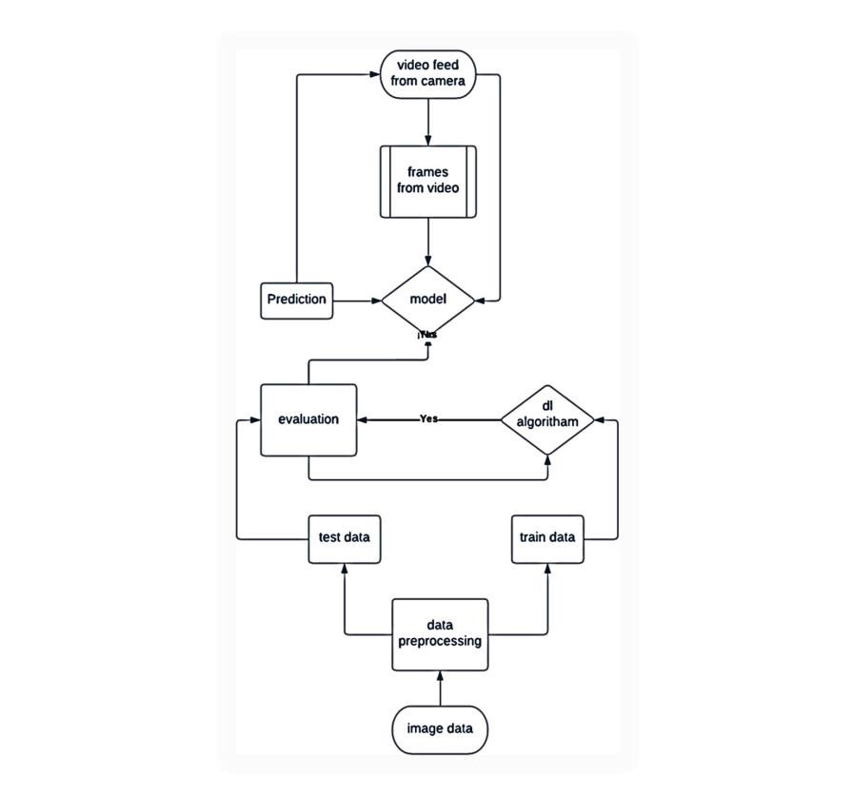

#### 3.2 USER STORIES

A user story is an informal, general explanation of a software feature written from the perspective of the end user or customer. The purpose of a user story is to articulate how a piece of work will deliver a particular value back to the customer**.**

|  |  |  |  |  |  |  |
| --- | --- | --- | --- | --- | --- | --- |
| **User**  **Type** | **Functional**  **Requirement**  **(Epic)** | **User**  **Story**  **Number** | **User Story / Task** | **Acceptance**  **criteria** | **Priority** | **Release** |
| Customer (Mobile user) | LOGIN | USN-1 | As a farmer, I can login by giving mobile number, gmail or google account and their location. | I can prepare myself from cyclone and  storing enough food and essentials | High | Sprint- 1 |
|  | ALERT | USN-2 | As a farmer, I can receive the alert message when the cyclone hits. | I can know about current climatic conditions and upcoming weather conditions | High | Sprint- 2 |
|  | MONITORING | USN-3 | As a farmer, I can view the continuous monitoring of cyclone and  climatic changes. | I can know where the  cyclone hits and how much impacts it may creates | High | Sprint- 3 |
|  | REPORTS | USN-4 | As a farmer, I can keep the records of the previous cyclone and refer news from  meteorologist for  live updation. | I can receive the alert  messages when the disaster occurs | High | Sprint- 4 |
|  | END USERS  (farmers) | USN-5 | As a farmer, I can receive the information from the database. | I should ensure that any stored seeds or harvested crops are carefully protected from  wind and flooding | High | Sprint- 5 |

**3.3 SOLUTION AND TECHNICAL ARCHITECTURE**

## SOLUTION ARCHITECTURE

A solution architecture (SA) is an architectural description of a specific solution. SAs combine guidance from different enterprise architecture viewpoints (business, information and technical), as well as from the enterprise solution architecture (ESA).

## TECHNOLOGY STACK

A tech stack is the combination of technologies a company uses to build and run an application or project. Sometimes called a “solutions stack,” a tech stack typically consists of programming languages, frameworks, a database, front-end tools, back-end tools, and applications connected via APIs.

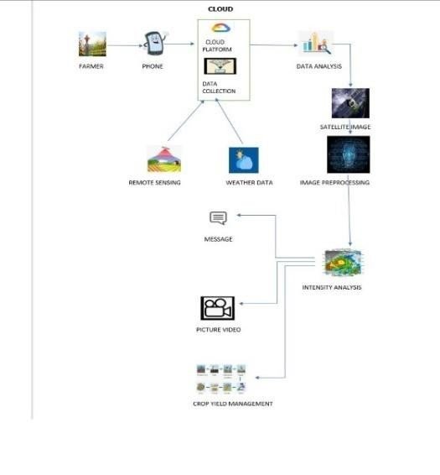

## 4. PROJECT PLANNING AND SCHEDULING

### 4.1 SPRINT PLANNING AND ESTIMATION

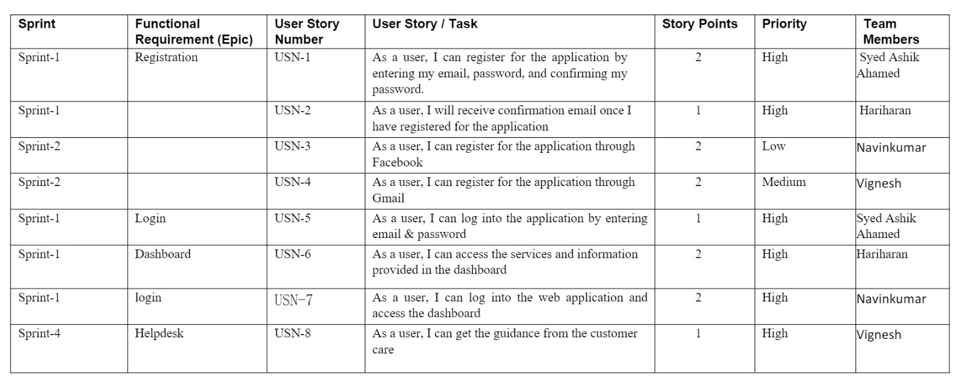

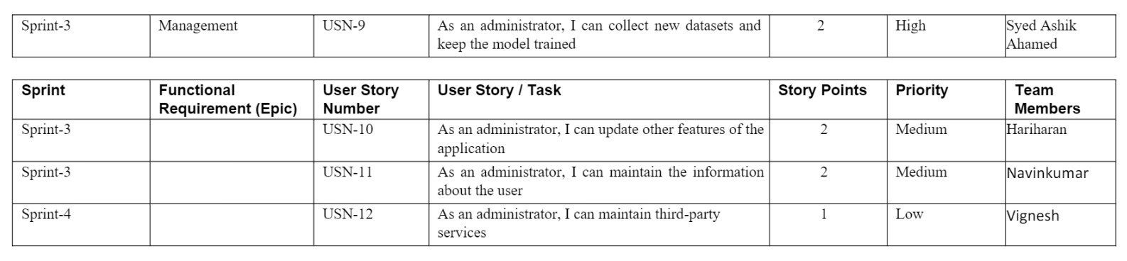

### 4.2 SPRINT DELIVERY SCHEDULE

|  |  |  |  |  |  |
| --- | --- | --- | --- | --- | --- |
| **Sprint** | **Total**  **Story**  **Points** | **Duration** | **Sprint**  **Start**  **Date** | **Sprint**  **End**  **Date**  **(Planned)** | **Story**  **Points**  **Complet** **ed (as on**  **planned**  **End Date)** |
| Sprint 1 | **8** | **6 Days** | **26 Oct**  **2022** | **31 Oct**  **2022** | **8** |
| **Sprint 2** | **4** | **6 Days** | **01 Nov**  **2022** | **06 Nov**  **2022** | **4** |
| **Sprint 3** | **6** | **6 Days** | **07 Nov**  **2022** | **12 Nov**  **2022** | **6** |
| **Sprint 4** | **2** | **6 Days** | **13 Nov**  **2022** | **18 Nov**  **2022** | **2** |

### 4.3 REPORTS FROM JIRA

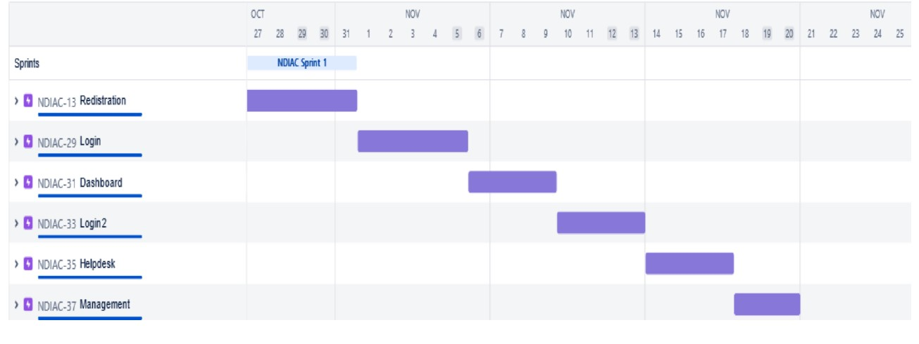

## 5. CODING AND SOLUTIONING

**5.1 FEATURE 1:**

**HTML**

**Home page:**

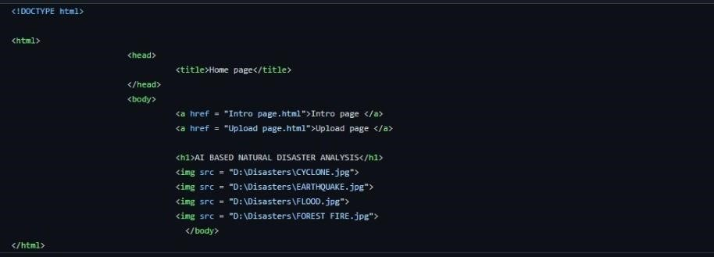

**Intro page:**

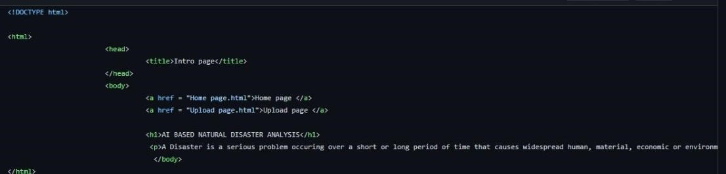

**Upload page:**

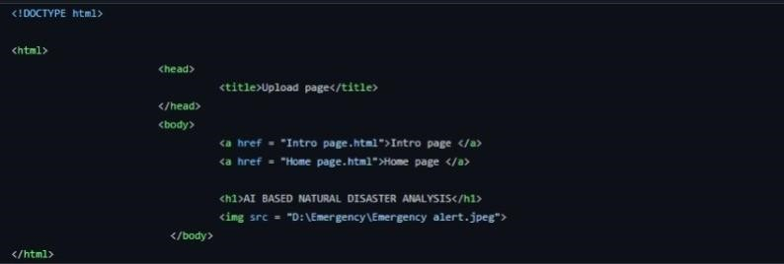

**5.2 FEATURE 2:**

**PYTHON**

from flask import Flask, render_template,request import cv2 import tensorflow from tensorflow.keras.models import load_model from werkzeug.u ls import secure_filename app= Flask(__name__,template_folder="templates") model=load_model('disaster.h5') print("Loaded model from disk") @app.route('/', methods=['GET']) def index(): return render_template('home.html') @app.route('/home', methods=['GET']) def home(): return render_template('home.html') @app.route('/intro'. methods['GET']) def about(): return render_tempalte('intro.html') @app.route('/upload', methods=['GET', 'POST'])

def predict(): cap= cv2.VideoCapture(0) while True:

_, frame = cap.read() frame = cv2.flip(frame,1) while True:

(grabbed, frame) =vs.read() if not grabbed:

break

if W is None or H is None: (H,W) = frame.shape[:2] output = frame.copy() frame = cv2.cvtcolor(frame, cv2.color_BGR2RGB) frame = cv2.resize(frame, (64,64)) x= np.expand_dims(frame, axis=0) result = np.argmax(model.predict(x), axis=-1) index = {'Cyclone','Earthquake','Flood','Wildfire'} result = str(index[result[0]]) cv2.putText(output, "ac vity: {}", format(result), (10,120), cv2.FONT_HERSHEY_PLAIN,1, (0,255,255), 1)

cv2.imshow("Output", output) key = cv2.waitkey(1) & 0xFF if key == ord("q"):

break print("[INFO] cleaning up...") vs.release() cv2.destroyAllWindows() return render_template("upload.html")

if __name__ == '__main__' :

app.run(host='0.0.0.0', port=8000, debug=False)

## 6. TESTING

### 6.1 TEST CASES

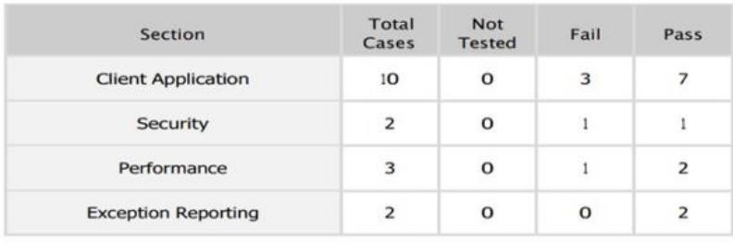

### 6.2 USER ACCEPTANCE TESTING

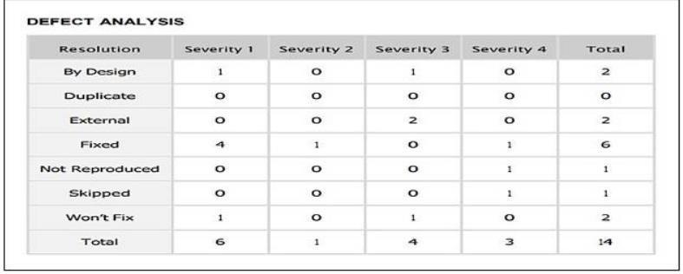

## 7.RESULTS

**7.1 PERFORMANCE METRICS**

### Locust Test Report

**During:** 11/20/2022, 12:20:34 PM - 11/20/2022, 12:29:21 PM

**Script**:: locustfile.py

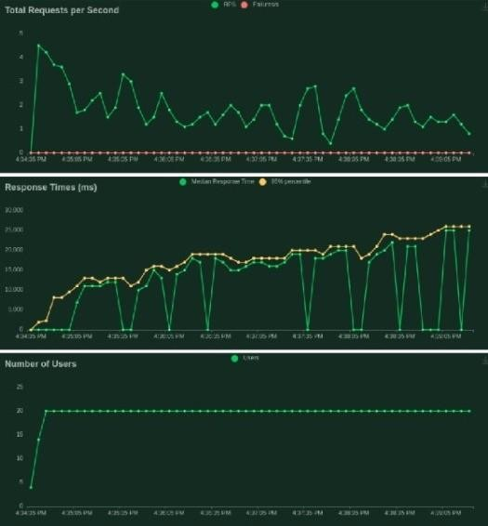

## 8. CONCLUSION

Artificial intelligence has the potential to enhance the detection and classificationof natural disasters, as well as the resilience and relief efforts

of affected communities. By using deep learning techniques, AI can analyze complex and imbalanced images of disasters and provide accurate and timely information. However, AI also faces challenges such as data quality, ethical issues, and human-AI collaboration. Therefore, it is essential to develop robust and reliable AI systems that can complement human expertise and judgment in disaster management.

AI can help predict the occurrence and impact of natural disasters by using historical data, satellite imagery, and weather models. This can enable early warning systems and preparedness plans for vulnerable areas. AI can also assist in the recovery and reconstruction of disaster-affected regions by providing insights into the needs and priorities of the survivors, as well as the best allocation of resources and funds.

AI can also support the learning and improvement of disaster management practices by analyzing the lessons learned from past disasters and identifying the gaps and opportunities for future interventions.

## 9. FUTURE SCOPE

To develop more advanced and efficient deep learning models that can handle the complexity and diversity of natural disaster images, and provide accurate and reliable results.

To integrate multiple sources and types of data, such as text, audio, video, and sensor data, to enhance the analysis and classification of natural disasters and their impacts.

To explore the ethical and social implications of using AI for natural disaster management, such as the privacy, security, and accountability of the data and the algorithms, and the potential biases and risks of the AI outputs.

To evaluate the performance and impact of AI for natural disaster management, and compare it with other methods and tools, such as human experts, traditional models, and manual processes.

To foster the collaboration and communication among different stakeholders, such as researchers, practitioners, policymakers, and communities, to share the best practices and challenges of using AI for natural disaster management, and to co-create solutions that meet the needs and expectations of the users.

To promote the awareness and education of the public and the decision-makers on the benefits and limitations of AI for natural disaster

management, and to encourage the participation and feedback of the affected people and groups.

* **THANK YOU**